CONTROL PANEL ASSEMBLY NEW STYLE 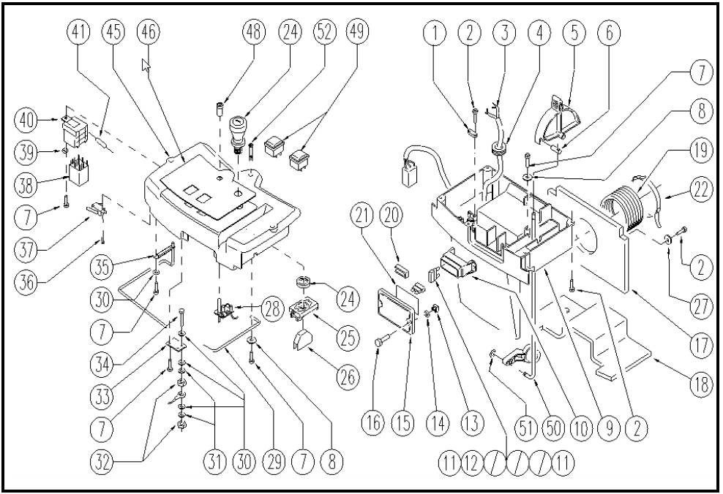

 | ITEM | SKU | DESCRIPTION | QTY | FROM
 | 1 | LAFN05201 | CABLE CLAMPING BLOCCACAVO | 1 | 09/2004
 | 2 | VTVT28553 | SCREW TCB-TC 3.5X16 | 8 | 09/2004
 | 3 | E89293 | Wiring WS20 | 1
 | 4 | MEVR01331 | FAIR-LEAD PVC | 1 | 09/2004
 | 5 | MPVR03845 | LEVER REGOLAZ. | 1 | 09/2004
 | 6 | LAFN05103 | ARTICULATION SUPERIORE | 1 | 09/2004
 | 7 | VTVT07859 | SCREW TCB-TC 3.5X13 UNI6954 | 6 | 09/2004
 | 8 | E86448 | AS20 Washer | 2 | 09/2004
 | 9 | MPVR03844 | PANEL COMANDI | 1
 | 10 | E89468 | Fuse Carrier | 1
 | 11 | E89342 | Fuse 30 Amp | 3 | 09/2004
 | 12 | E86647 | Fuse 40A | 2 | 09/2004
 | 13 | E87830 | Nut | 2 | 09/2004
 | 14 | GUGO00150 | NUT | 2 | 09/2004
 | 15 | E86543 | Fuse Cover for AS20 | 1 | 09/2004
 | 16 | E87877 | Screw WS20/24 FS28/32 | 2 | 09/2004
 | 17 | ITSO00031 | SOUND-PROOFING | 1 | 09/2004
 | 18 | ITSO00032 | SOUND-PROOFING | 1 | 09/2004
 | 19 | E88420 | Hose, Vacuum Motor Exhaust Vent | 1
 | 20 | MEVR01153 | FUSE FUSIBILI | 1 | 09/2004
 | 21 | ETET01352 | LABEL FUSIBILI | 1 | 09/2004
 | 22 | FSVR00083 | CLAMP 62-82 | 1
 | 24 | E86988 | Operator D22 Mushroom complete | 1
 | 25 | E86988 | Included With E86988 | 1 | 09/2004

